CAREER PORTFOLIO ORDER FORM
Date: __________________

School District
Contact
Shipping Address
Billing Address
Phone Number | ( ) - Ext.:
Email

Portfolio Costs: Member school district: $1.50 ea.
Non-member district: $2.25 ea.

Item | Quantity | Price Each | Subtotal
Career Portfolio Grades K-5
Career Portfolio Grades 6-12
Other
TOTAL

- Check Enclosed
- Please invoice us

Shipping instructions: __________________________________________________________

- For Pick Up at the Capital Area Intermediate Unit (please call to schedule)

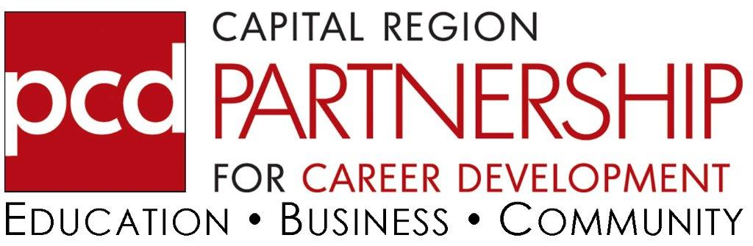
Send or email form to:
Capital Region Partnership for Career Development
55 Miller Street, Enola, PA 17025
info@crpcd.org

Internal Use Only:
Date rcvd: Payment rcvd: Order fulfilled:

